Technological Institute of the Philippines

938 Aurora Blvd. Cubao, Quezon City

College of Information Technology Education

IT 004 – Web Systems and Technologies

Preliminary Period

Designing Web Pages using HTML and CSS

| Name: SURNAME, FIRSTNAME MI  SURNAME, FIRSTNAME MI | Date: |
| --- | --- |
| Program / Section: | Instructor: Ms. Roxanne A. Pagaduan |
| Assessment Task: Practice Set No. 1 | |

**Instructions:**

* Provide screenshots to satisfy the requirements.
* Include your FULLNAME in every screenshot.
* Include a brief description in each screenshot.
* Save your work as **SURNAME1_SURNAME2_PS1.DOC** (Ex. PAGADUAN_ANCHETA_PS1.DOC and .PDF)

**Overview:**

HTML stands for Hyper Text Markup Language. It is a markup language for creating web pages and other information that can be viewed in a web browser. HTML is not a programming language since it uses a markup tags to describe web pages. HTML tags are used to interpret the content of the page in which the browser reads as the HTML documents and displays them as a web page. HTML tags can come in pairs the first tags for the start and the next tags is for end part and surrounded by <angle-brackets>.

HTML element indicates structure in an HTML document. More specifically, it is an SGML element that meets the requirements of one or more of the HTML Document Type Definitions (DTDs). HTML elements generally consist of three parts: a *start tag* marking the beginning of an element, some amount of *content*, and an *end tag*. Elements may represent headings, paragraphs, hypertext links, lists, embedded media, and a variety of other structures.

Cascading Style Sheets or known as CSS is a style sheet that allows the developer or the user to change and modify the looks and style of the webpage. It is one of the important parts of the webpage that allows the creator of the webpage to easily modify their webpage by accessing the CSS file and the html document that will read the CSS file and change the style and the looks of the webpage accordingly. Updating a webpage can be much easier because only the part that the creator needs to modify is the CSS file and not the whole HTML code and with this it avoids errors caused by editing the html code.

**Requirements:**

1. Create a web document that contains the lyrics of your favorite song. Use the following CSS properties: background, padding, margin, border and font. (save your work as PS1-lyrics.html)

Sample Output:

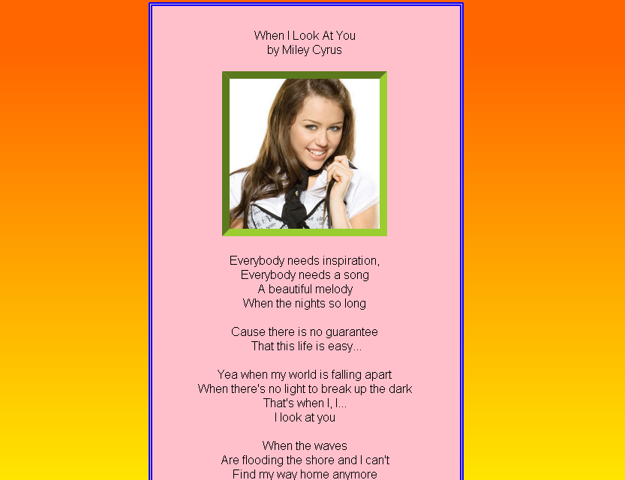

1. Create a homepage for the flower shop using HTML and CSS. *(****note:*** *you can download any related images on the internet)*. Acknowledge references. Save your work as PS1-flowershop.html



**Assessment Tool:**

This assessment will be graded using the Rubric for Laboratory Performance in Web Systems and Technologies.

**Answer:**

**Source Code:**

<paste your source code>

<screenshot of source code>

**Sample Output:** (running in the web browser)